**MASTER’S IN INFORMATION SYSTEMS**



**COURSE: BIS580-Data Modelling Design**

**CLIMATE CHANGE ANALYSIS PROJECT**

**GROUP – 1**

|  |
| --- |
| April 28, 2024 |

Professor Kenneth Desloover

**Table of Contents**

**Topics Page**

1. Introduction……………………………………………………………3

2. Executive Summary…………………………………………………...3

3. Problem Statement…………………………………………………….4

4. Analysis……………………………………………………………….4

4.1 Linear Regression………………………………………………….4

4.2 Probability and statistics…………………………………………...5

4.3 Sensitivity analysis ………………………………………………..6

4.4. Optimization……………………………………………………....7

4.5 Forecasting…………………………………………………….......10

5. Recommendations…………………………………………………..…11

6. Conclusion………………………………………………………..……12

7. References……………………………………………………………...13

**1.** **Introduction:**

The Climate Change initiative endeavors to mitigate the global temperature rise to a maximum of 2°C by 2100, a critical goal necessitating significant human behavioral shifts and policy reforms. Drawing upon an extensive toolkit of data analysis tools in Excel, including optimization techniques, forecasting, probability and statistics, and sensitivity analysis, we meticulously assess carbon emissions across vital sectors such as energy supply, transportation, land use, and industry. By meticulously manipulating key parameters within these sectors, we generate robust forecasts of carbon emissions over diverse timeframes. Our analysis harnesses advanced forecasting methodologies like t-testing significance and ANOVA, providing invaluable insights to refine predictions and facilitate the development of targeted mitigation strategies.

**2.** **Executive Summary**

This project delves into the pressing issue of climate change, aiming to prevent the global temperature from surpassing a 2°C increase by 2100. The summary outlines key findings, conclusions, and recommendations for policy and action to achieve this critical goal.

The findings highlight the alarming trajectory of greenhouse gas emissions, indicating a potential temperature rise exceeding the 2°C threshold if current emission rates persist. Human activities such as fossil fuel consumption, deforestation, and intensive agriculture are identified as significant contributors to the accumulation of greenhouse gases in the atmosphere.

In response to these findings, urgent policy and behavioral changes are deemed necessary to mitigate and ultimately halt the rise in global temperature. Central to this effort is a transformation of the energy sector, prioritizing the phasing out of coal in favor of renewable energy sources like solar and wind power. Additionally, implementing carbon pricing mechanisms is advocated to incentivize emission reduction and facilitate the transition to cleaner energy alternatives.

The recommendations put forward encompass various sectors and initiatives. They include stringent regulations against coal usage, investment in innovative energy technologies such as nuclear and fusion power, and policies that balance economic growth with environmental sustainability. Furthermore, advocating for carbon pricing, sustainable land management practices, and the development of carbon capture technologies are highlighted as essential strategies.

These proposed measures have the potential to influence climate change simulation models and contribute to progress towards the 2°C target. The project underscores the critical role of scientific innovation, policy interventions, and societal transformations in effectively addressing climate change challenges.

**3. Problem Statement**

Climate change is a big problem that we're facing globally, and a lot of it comes from things people do, like burning natural gas, oil, and coal. When these fuels burn, they release gases that trap heat in the atmosphere, which makes the Earth's average temperature go up. We need to keep this temperature increase to no more than 2 degrees Celsius and to do that, we need good environmental rules. We have to study important factors and use tools to help us decide what policies to make. This study will look at how things like coal, nuclear power, and natural gas affect temperature changes. The goal is to find the best ways to reach our temperature target.

**4. Analysis**

**4.1 Linear Regression**

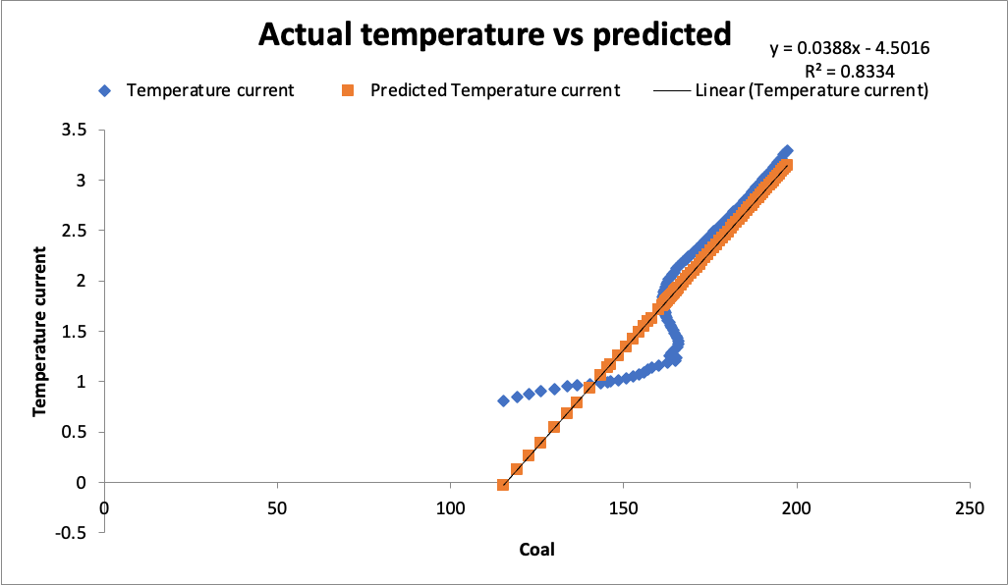

Figure: Linear Regression Graph

The chart you uploaded shows how temperature changes as coal usage increases. The x-axis represents coal usage, while the y-axis shows temperature. The blue diamonds are the actual temperature values, and the orange squares are the predicted values based on a line drawn through the data points.

The equation at the top right of the chart, \(y = 0.0388x - 4.5016 \), tells us how temperature changes with coal usage. For every unit increase in coal usage, the temperature goes up by about 0.0388 units. The number -4.5016 is where the line crosses the y-axis, showing the temperature when no coal is used.

The \( R^2 \) value of 0.8334 means that about 83.34% of the temperature changes can be explained by coal usage. The closer this value is to 1, the better the model fits the data.

The line on the chart shows a strong relationship between coal usage and temperature. This model could help predict temperature changes based on future coal use or understand how coal has affected temperature in the past.

**4.2** **Probability and Statistics**

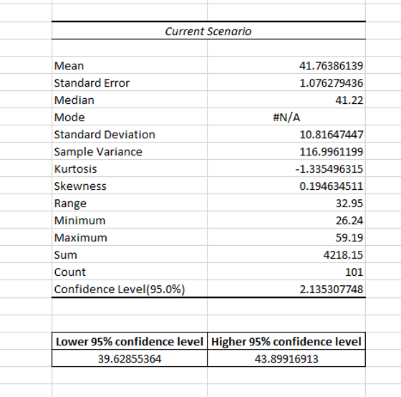

Figure: Probability and Statistics.

The image shows data about greenhouse gas (GHG) emissions measured in gigatons of CO2 equivalent per year. It compares two scenarios: Baseline and Current Scenario, from 2000 to 2100.

The Baseline scenario represents expected emissions without any changes, while the Current Scenario likely reflects actual or predicted emissions with current policies and technology.

From 2000, both scenarios start similarly but diverge later, indicating that actions in the Current Scenario lead to lower emissions compared to the Baseline.

The statistics for the Current Scenario show:

- Average emissions: about 41.76 gigatons CO2 equivalent/year.

- Variation: with a standard deviation of approximately 10.82 gigatons.

- Range: from a minimum of 26.24 to a maximum of 59.19 gigatons.

- Confidence: the mean's estimated range is about 2.14 gigatons, with 95% certainty it falls between 39.63 and 43.90 gigatons.

These stats describe the data's average, spread, and distribution shape, suggesting that the Current Scenario's policies or technologies may reduce emissions compared to the Baseline.

**4.3 Sensitivity Analysis**

**Sensitivity Analysis**: A method used to identify and quantify the impact of variations or uncertainties in input parameters on the output of a mathematical model or simulation. It helps in understanding how changes in certain variables affect the overall outcome or results of the model.

In other words,

Sensitivity analysis: Unveiling the key influencers in a model's uncertainty.

Sensitivity Graph tool: Visualizing confidence bounds or multiple traces of influence.

Exploring uncertainty: Understanding how different factors affect overall model uncertainty.

Insights revealed: Each analysis peels back layers of uncertainty, clarifying our understanding of the model's dynamics.

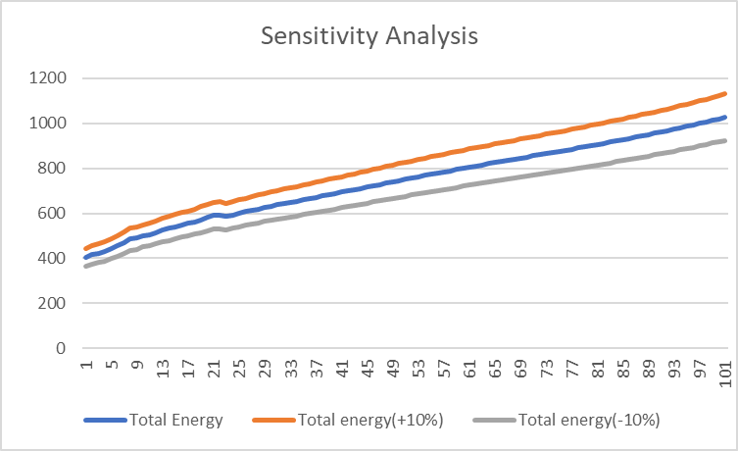

Figure: Sensitivity Analysis Graph.

The sensitivity analysis conducted on the total energy output demonstrates a direct correlation between variations in input parameters and resulting output. The graph illustrates a linear relationship, indicating that adjustments in the total energy input directly influence the total energy output. Notably, an increase or decrease of 10% in the input parameter leads to a corresponding change of approximately 10% in the output. This finding underscores the system's responsiveness to changes in input conditions. Understanding this sensitivity is crucial for informed decision-making, as it allows stakeholders to anticipate and optimize system performance based on varying input scenarios.

**4.4 Optimization of the Decision Model:**

The key objective of this project is to accomplish a temperature of approximately 2 degrees Celsius within the year 2100 by modifying energy regulations. To avoid overspending and inflation, we must also maintain the ideal values for independent variables including coal tax, oil tax, renewables subsidy, and so on. Using Excel's solver, we can calculate the lowest probable temperature we can attain by the end of 2100 while limiting the input variables.

Variables used in making decisions:

1. Coal tax

2. Oil tax

3. Renewables Subsidy

4. Carbon Price

5. Transport Energy Efficiency

6. Buildings Energy Efficiency

7. Methane Reduction

Objective capability: Reduce the world's temperature to 2 degrees Celsius by 2100 by distributing optimal values for energy programs.

Limitations:

1. 0$ <= Coal Tax ($/tce) < 35$

2. 0$ <= Oil Tax ($/boe) < 30$

3. -0.03 <= Renewables Subsidy ($/kWh) <= 0

4. 0 <= Carbon Price ($/ton) <= 40

5. 0 <= Transport Energy Efficiency (per year) <= 3%

6. 0 <= Buildings Energy Efficiency (per year) <= 3%

7. -50% <= Methane Reduction <= 0

Optional and important limitations to consider:

1. -2.5% <= Deforestation (%/year) <= 0

2. 0 <= Afforestation (%/year) <= 30%

3. 0 <= Technological carbon removal (% of max potential) <= 30%

Optimization Model: By 2100, the temperature would have to be as low as 2°C.

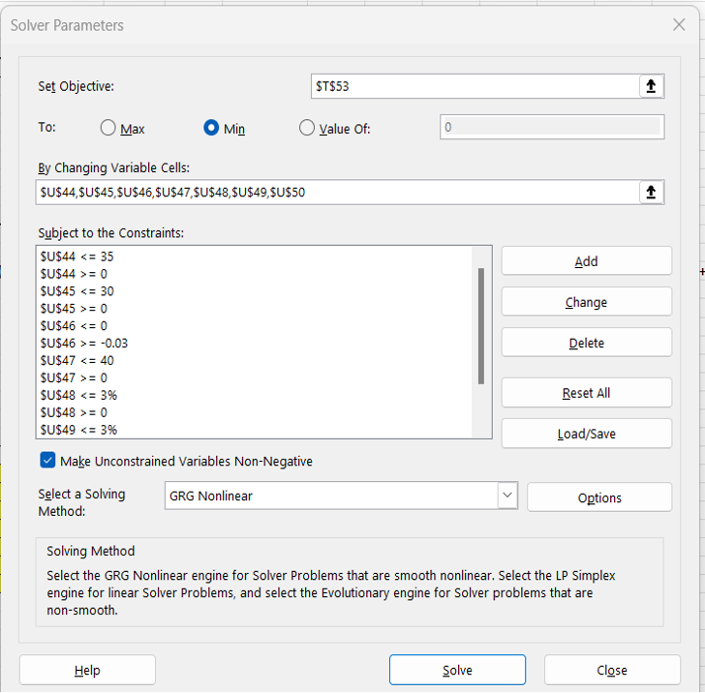

Figure: Inserting the constraints into the solver tool.

Using the solution, we may determine the temperature by 2100 which will be as low as possible while adhering to the following requirements.

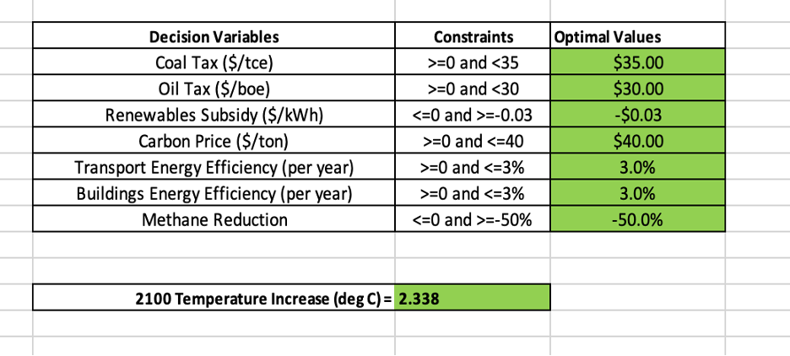

Figure: Optimal parameters and least feasible temperature.

The cells indicated in green in the Excel report above show our model's optimal values. The lowest temperature that can be achieved by applying the limits to energy strategies is 2.34 degrees Celsius. However, we may be able to decrease the temperature by improving the rules further, but to avoid overspending and inflation, energy policies must be as environmentally conscious as feasible.

We can still reduce global temperatures by 2100 by implementing three more policies: limiting deforestation, boosting afforestation, and CO2 removal technology. It demonstrates that revising these rules to a potential threshold can have an impact on a cumulative temperature increase of up to 2.1 degrees Celsius by 2100.

**4.5 Forecasting**

A forecasting tool is a software or a system crafted to examine past data and patterns, enabling the prediction of future trends or outcomes. It employs diverse algorithms, statistical models, and data analysis techniques to forecast based on historical data. These tools are widely utilized across business, finance, economics, weather forecasting, and other domains where the ability to predict upcoming events or trends is critical for making informed decisions.

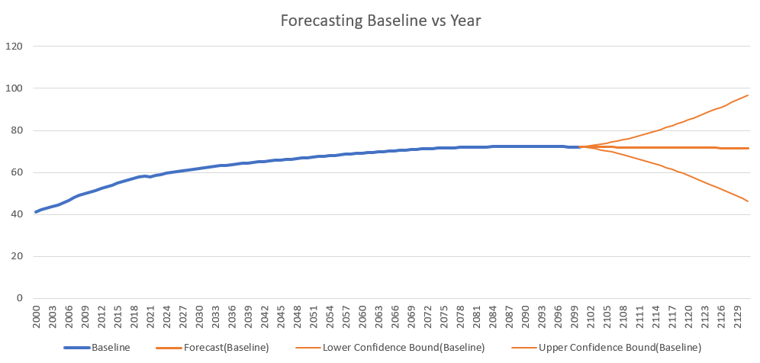

Figure: Forecasting Graph.

The baseline forecast is the main prediction line showing expected greenhouse gas emissions over time if current trends persist, serving as a benchmark for comparing other forecasts. The forecast (baseline) likely shows a smoothed version of this main forecast, offering a clearer trend with less variability than the raw data. The lower confidence bound indicates potential emissions outcomes below the baseline due to statistical confidence levels or interventions. Conversely, the upper confidence bound represents potential emissions outcomes above the baseline due to various factors. Forecasting in this context helps stakeholders grasp potential future greenhouse gas emission scenarios, aiding informed decision-making and environmental planning.

**5. Recommendations**

To keep the global temperature from rising more than 2°C by 2100, we need to make big changes in different areas. These changes are all about cutting down on greenhouse gases and lessening the bad effects of climate change. We have to adjust policies, use new technologies, and change how we behave to reach this tough goal.

1. *Change How We Get Energy*:

- Make strict rules to use less coal and close down coal power plants faster.

- Give more money and support to solar and wind power so they can compete better with coal.

- Invest in new ideas like better nuclear power and fusion energy to find other ways to make energy without fossil fuels.

2. *Control Population Growth and Economy*:

- Support rules that help keep the population from growing too fast and make sure economic growth doesn't harm the environment.

- Invest in technologies and industries that don't harm the environment while growing the economy.

3. *Put a Price on Carbon Emissions*:

- Make companies pay for the pollution they make with carbon taxes or by trading emissions. This will make them want to pollute less and find cleaner ways to do things.

4. *Use Land Wisely and Pollute Less*:

- Stop cutting down forests and start planting more trees to soak up carbon from the air.

- Find better ways to farm and manage waste to reduce other harmful gases besides carbon dioxide.

5. *Improve Carbon Capture Technology*:

- Create better ways to capture and store carbon dioxide from places like coal power plants and factories.

- Invest in making carbon capture technology work better and be used more widely in our energy systems.

If we make these changes in different areas, we can cut down on greenhouse gases a lot and keep the global temperature rise under 2°C by 2100. But it's going to take everyone working together—governments, businesses, and people—to make this happen and create a future that's better for the planet.

**6. Conclusion:**

The entire analysis revealed a continuous trend, a carbon emission value of 2.0 is a strong sign of an eco-conscious, low-impact environment. Our data-driven findings demonstrate a strong correlation: significant technological breakthroughs combined with dropping rates of population result in smaller carbon footprints. We analyzed carbon emissions across a wide range of sectors, including energy provision, transportation, the management of land, and industrial operations, using a variety of Excel analytical methods. By adjusting variables in these areas, we may anticipate the future trajectory of carbon emissions, providing insight into probable environmental repercussions.

**References**

"Introduction to the Practice of Statistics" by David S. Moore, George P. McCabe,

and Bruce A. Craig ISBN: 9781464158933

Driga, A. M., & Drigas, A. S. (2019). Climate Change 101: How Everyday Activities

Contribute to the Ever-Growing Issue. Int. J. Recent Contributions Eng. Sci. IT, 7(1), 22-31.

National Geographic Society (2022). *Climate Change.* National Geographic. Retrieved August 5,2023 from <https://education.nationalgeographic.org/resource/climate-change/>

"Statistics for Business and Economics" by Paul Newbold, William L. Carlson, and Betty Thorne ISBN: 9780134040319